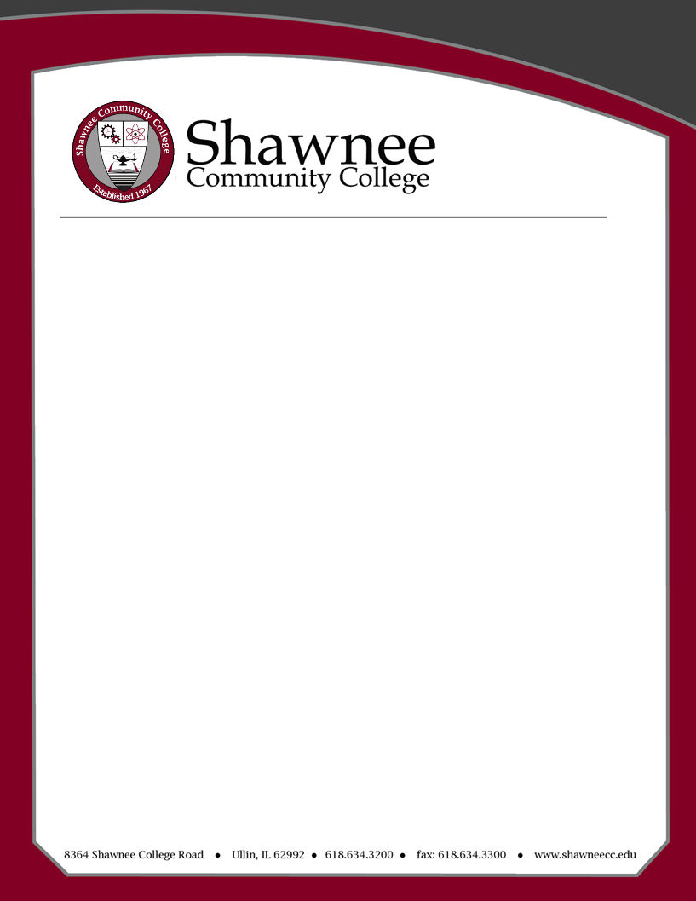

START TIME | AGENDA | PRESENTING
9:00 a.m. | Meet with Human Resources and Payroll | HR Staff
10:00 a.m. | Academic Affairs Handbook Review | VPAA
11:00 a.m. | Lunch with Vice President and Deans | VPAA and Deans
12:30 p.m. | Introduction to Technology Tools-  MySCC, Help Desk, Moodle, Simple Syllabus, Smart Evals | Ed Tech Coordinator
1:15 p.m. | Assessments- Student Academic Assessment Handbook | Assessment Coordinator
2:00 p.m. | Student Affairs Overview – How can they help you and your students? (Library, Career Services, Advising, Testing, Counseling) | VPSA
2:10 p.m. | Administrative Services Overview – How can they help you and your students? (Bookstore services, Student billing, paying bills, getting account numbers, maintenance services) | VPAS
2:20 p.m. | Campus Tour | Executive Assistant to VPAA
2:45 p.m. | Schedule/Section Assignments, Office Assignments, Office Schedules | Deans/Chairs
3:30 p.m. | Adjourn-  Collective Bargaining Agreement Review | SCEA Representative

Faculty Orientation
August 5, 2024

